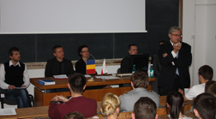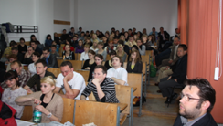  The image from 12th edition of seminar in 2012  15.00- 18.00: Thematic Fieldtrip: Oradea Tour in Old Center  19.00 – 20.00: Tineretului Stadium (Liceul cu program Sportiv) Traditional Yearly Footbal match:   „Geographers” of Gdansk University  versus  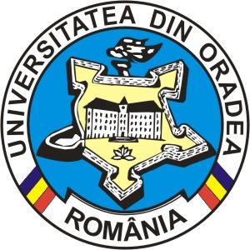 „Geographers” of Oradea University  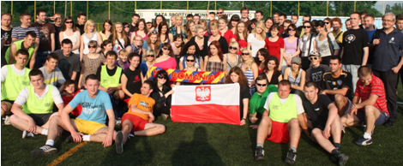  The suporters and teams from 2011  28 May -29 May, 2013: Thematic field trip in Transylvania: Oradea – Bear Cave – Ariesul Valley – Turda Salt Mine - Cluj-Napoca-Oradea |  | organizing  The 13th Edition of International  Romanian-Polish Geographical Seminar  Geography, Society and Regional Development  Dedicated to PhD Students  27 May – 29 May, 2013  Oradea, Romania  Contact address: University of Oradea, Department of Geography, Tourism and Territorial Planning, Cezar MORAR, 1 University st., 410087 Oradea, Romania, tel./fax (40)(259) 408475, e-mail: cezarmorar@yahoo.com
  University of Oradea,  Romania  Doctoral School in Geography  Department of Geography, Tourism and Territorial Planning  Faculty of Geography, Tourism and Sport  University of Oradea,  Romania | University of Gdansk,  Poland  Doctoral School in Geography  Department of Geography and Regional Development,  Institute of Geography  Faculty of Oceanography  and Geography  University of Gdansk,  Poland
Honourably Patronage:  Professor BUNGĂU Constantin, Rector of the University of Oradea  Professor WĘGRZYN Grzegorz, Vice-Rector of the University of Gdansk  Professor CURILĂ Sorin – President of The Senat of University of Oradea  Directors of Seminar:  Professor ILIEŞ Alexandru – University of Oradea/Gdansk  Professor WENDT Jan – University of Gdansk/Oradea  Dr. MORAR Cezar – University of Oradea  Dr. HERMAN Grigore Vasile – University of Oradea  Scientific Committee:  Professor ILIEŞ Alexandru, University of Oradea  Professor JOSAN Nicolae, University of Oradea  Professor KISTOWSKI Mariusz, University of Gdansk  Professor MĂHĂRA Gheorghe, University of Oradea  Professor MICHALSKI Tomasz, University of Gdansk  Professor OLARU Martin, West University of Timişoara  Professor PALMOWSKI Tadeusz, University of Gdansk  Professor PETREA Rodica, University of Oradea  Professor WENDT Jan, University of Gdansk  Professor ZARILLI Luca, University of Chieti-Pescara (Italy)  Assoc. Prof. GACEU Ovidiu, University of Oradea  Assoc. Prof. ILIEŞ Dorina, University of Oradea  Assoc Prof. STAŞAC Marcu, University of Oradea  Assoc Prof. TARKOWSKI Maciej, University of Gdansk  Dr. KOROWICKI Antoni, University of Gdansk  Dr. BLAGA Lucian, University of Oradea  Dr. JOSAN Ioana, University of Oradea  Dr. VLAICU Mihai, University of Oradea  Dr. GRAMA Vasile, University of Oradea  Organizing Committee:  Dr. GOZNER Maria, Dr. TĂTAR Corina, Dr. STUPARIU Marius, PhD Student BAIAS Iuliana, PhD Student BAR-KOLELIS Delia, PhD Student BAIAS Stefan, PhD Student PRAŞCA Mariana, PhD Student MOJOLIC Diana, MĂDUŢA Florin |  | The Programme:  9.00. Official Opening ( C 219 Hall, C Building of the University of Oradea)  - Professor BUNGĂU Constantin, Rector of the University of Oradea  - Professor CURILĂ Sorin – President of the Senat of University of Oradea  - Professor ŞIPOŞ Sorin, Vice-Rector of the University of Oradea  - Professor BĂDULESCU Alina – Director of the Doctoral Studies School, University of Oradea  - Professor WENDT Jan, Vice-Dean of the Faculty of Oceanography and Geography, University of Gdansk  - Professor ILIEŞ Alexandru, Dean of the Faculty of Geography, Tourism and Sport, University of Oradea  -Professor PETREA Rodica, Director of Doctoral School in Geography, University of Oradea  -dr. VLAICU Mihai, Director of Department of Geography, Tourism and Territorial Planning, University of Oradea  9.30. GRAMA Vasile, Evolution of academic relations in Geography field between University of Oradea and University of Gdansk at the begining of the IIIrd millenium  10.00. Session. Chairmans: dr. MORAR Cezar, dr. KOROWICKI Antoni  10.30-10.50: BAR-KOŁELIS Delia, (University of Gdańsk),  Border-shopping tourism in Timişoara  10.50-11.10: MOJOLIC Diana (University of Oradea)  Opportunities of local development using natural and anthropogenic resources in tourism activities. Case study: Ulmeni (Maramureş)  11.10-11.30: GRABOWSKA Katarzyna (University of Gdansk, Poland)  The evolution of lake water quality classification system in Poland since 2004  11.30-11.50: WISKULSKI Tomasz (University of Gdańsk),  Changes in the volume of tourist traffic from Poland to Split-Dalmatia Region in the period 2002-2011  11.50-12.10: PRAŞCA Mariana (University of Oradea)  Alternatives of smart urban shrinkage for towns of NUcet and Vaşcău (Bihor County)  12.10-12.30: SZMAGLINSKI Jacek (University of Gdańsk),  Improvement of tram track design, based on satellite surveying  12.30-12.50: MĂDUŢA Florin (University of Oradea)  The Analyze of the ciclotiurist potential in the Oradea Metropolitan Zone  12.50-13.00. Discutions. Conclusions

